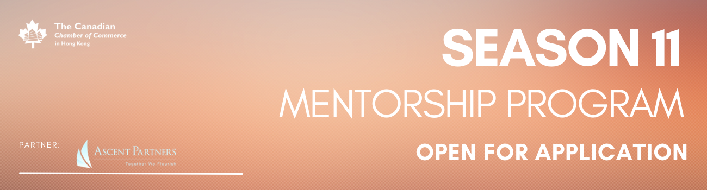

Mentor Application
This Mentorship Program welcomes Mentors who are existing CanChamHK Members or non-members. Mentors will receive an email confirmation regarding their received application.

- Please indicate with an ‘X’ that you are a CanChamHK Member (Corporate, Entrepreneur, Individual?

____Yes, I am
____No, I am not

- First Name

- Last Name

- Email

- Contact Number

- Job Title

- Company

- LinkedIn Proﬁle Link

- How would you describe your professional industry? Please indicate with an ‘X’, one of the following options

__Accounting and Financial Services
__Advertising, Marketing, Media and Communication __Art, Architecture and Design
__Construction & __Infrastructure Education
__Engineering __Entrepreneur / Startup
__Export, Import and Trading __Health and Medical __Hospitality & Services __Human Resources
__Law
__Research and __Development Retail and __Sales
__Technology /Digital Solutions
__Other:

- Provide a short description of yourself that best describes you, both professionally and personally (approx 100-200 words). This will be shared with others.

- Please email us your CV/Resumé AND updated profile photo

To submit your application or if you have any questions please email events@cancham.org.
To speak to the Secretariat, please call 2110 8700 / 2110 8711.
You will receive an email from us to confirm your Mentor application.

