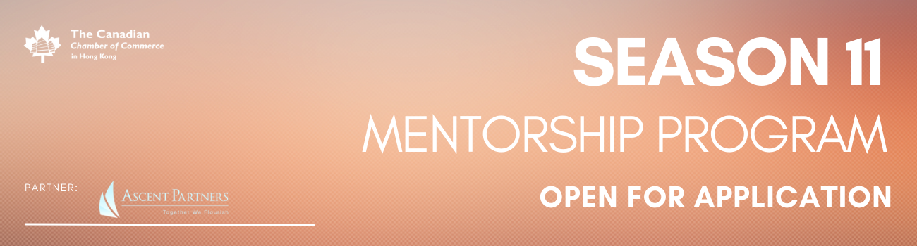

Mentee Application
Open to Corporates, Entrepreneurs, Individuals or Young Professionals with an active paid membership (application fee HKD 500)
Open to Affiliate Members or Non-Members (application fee: HKD 1,200) Click here to renew or sign up for a paid membership

- Please indicate with an ‘X’ that you are a CanChamHK Member (Corporate, Entrepreneur, Individual, or Young Professional)?

____Yes, I am
____No, I am not

- First Name

- Last Name

- Email

- Contact Number

- Job Title

- Company

- LinkedIn Proﬁle Link

- Provide a short description of why you decided to join the Mentorship Program
(approx 100-200 words).

- Please email us your CV/Resumé AND updated profile photo

To submit your application or if you have any questions please email events@cancham.org.
To speak to the Secretariat, please call 2110 8700 / 2110 8711.
You will receive an email from us to confirm your Mentee status and payment.

